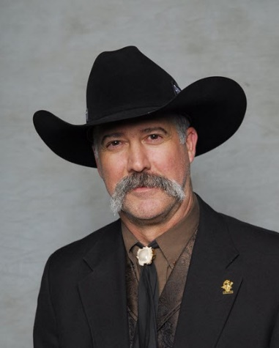
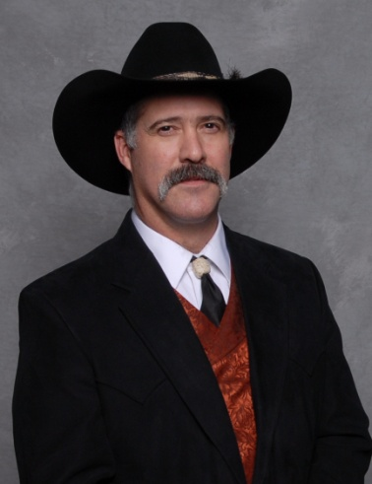
Meet Our Auctioneers….

John J. Nelson Rohn R. Nelson
John and Rohn Nelson are identical twins that have been professional Auctioneers since 1981. They graduated from Western College of Auctioneering in Billings Montana, where they both held top honors in their class.
Together, the Nelson Twins founded OPEN BUCKLE AUCTION SERVICE and have specialized in all types of auctions since 1981. Their objective, as your auctioneer, is to maximize the auction proceeds, generate interest in your organization, and provide a professional and positive atmosphere for your event.
John and Rohn have conducted auctions throughout the continental United States and Alaska. Their professional experience will clearly demonstrate the difference between a benefit auctioneer and a commercial auction service. OPEN BUCKLE AUCTION SERVICE offers a lively presentation and their entertaining antics will keep you and the rest of the audience actively involved and attentive.
Each year, John and Rohn both serve as the exclusive AUCTIONEERS at the prestigious Grand Slam Club - Ovis National Convention in Las Vegas, Nevada. They pride themselves in the fact that OPEN BUCKLE AUCTION SERVICE is featured each year, at several other NATIONAL CONVENTIONS including the Safari Club International Hunters Convention in Las Vegas, Nevada as well as the Rocky Mountain Elk Foundation's National Elk Camp and National Convention in Las Vegas, Nevada each year in December.

John and Rohn Nelson are co-owners of Open Buckle Auction Service and they would like to welcome you to tonight’s featured auction event! They would also like to thank you for your continued support of this fantastic organization, and wish you the very best in your bidding opportunities tonight. Thank you for all you do!

You are cordially invited to visit Open Buckle Auction Service at www.openbuckle.com.

Respectfully,

John and Rohn Nelson

